Day -3

11.#include <stdio.h>

#include <stdlib.h>

#include <unistd.h>

void print_odd_numbers() {

printf("Odd numbers: ");

for (int i = 1; i <= 10; i += 2) {

printf("%d ", i);

}

printf("\n");

}

void print_even_numbers() {

printf("Even numbers: ");

for (int i = 2; i <= 10; i += 2) {

printf("%d ", i);

}

printf("\n");

}

void print_multiples_of_3() {

printf("Multiples of 3: ");

for (int i = 3; i <= 30; i += 3) {

printf("%d ", i);

}

printf("\n");

}

void print_multiples_of_5() {

printf("Multiples of 5: ");

for (int i = 5; i <= 50; i += 5) {

printf("%d ", i);

}

printf("\n");

}

int main() {

pid_t pid1, pid2, pid3, pid4;

// create first child process

pid1 = fork();

if (pid1 < 0) {

fprintf(stderr, "Error creating first child process\n");

exit(EXIT_FAILURE);

} else if (pid1 == 0) {

// first child process

printf("First child process (pid=%d):\n", getpid());

print_odd_numbers();

exit(EXIT_SUCCESS);

}

// create second child process

pid2 = fork();

if (pid2 < 0) {

fprintf(stderr, "Error creating second child process\n");

exit(EXIT_FAILURE);

} else if (pid2 == 0) {

// second child process

printf("Second child process (pid=%d):\n", getpid());

print_even_numbers();

exit(EXIT_SUCCESS);

}

// create third child process

pid3 = fork();

if (pid3 < 0) {

fprintf(stderr, "Error creating third child process\n");

exit(EXIT_FAILURE);

} else if (pid3 == 0) {

// third child process

printf("Third child process (pid=%d):\n", getpid());

print_multiples_of_3();

exit(EXIT_SUCCESS);

}

// create fourth child process

pid4 = fork();

if (pid4 < 0) {

fprintf(stderr, "Error creating fourth child process\n");

exit(EXIT_FAILURE);

} else if (pid4 == 0) {

// fourth child process

printf("Fourth child process (pid=%d):\n", getpid());

print_multiples_of_5();

exit(EXIT_SUCCESS);

}

// wait for all child processes to finish

wait(NULL);

wait(NULL);

wait(NULL);

wait(NULL);

return 0;

}

Output

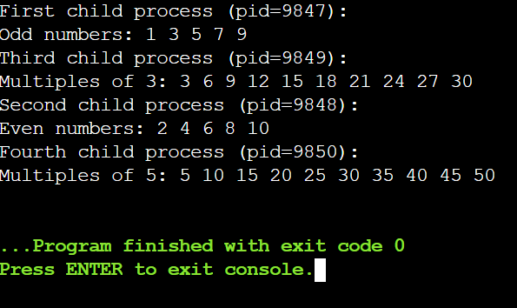

12. #include<iostream>

using namespace std;

int main()

{

int fragment[20],b[20],p[20],i,j,nb,np,temp,lowest=9999;

static int barray[20],parray[20];

cout<<"\n\t\t\tMemory Management Scheme - Best Fit";

cout<<"\nEnter the number of blocks:";

cin>>nb;

cout<<"Enter the number of processes:";

cin>>np;

cout<<"\nEnter the size of the blocks:-\n";

for(i=1;i<=nb;i++)

{

cout<<"Block no."<<i<<":";

cin>>b[i];

}

cout<<"\nEnter the size of the processes :-\n";

for(i=1;i<=np;i++)

{

cout<<"Process no. "<<i<<":";

cin>>p[i];

}

for(i=1;i<=np;i++)

{

for(j=1;j<=nb;j++)

{

if(barray[j]!=1)

{

temp=b[j]-p[i];

if(temp>=0)

if(lowest>temp)

{

parray[i]=j;

lowest=temp;

}

}

}

fragment[i]=lowest;

barray[parray[i]]=1;

lowest=10000;

}

cout<<"\nProcess_no\tProcess_size\tBlock_no\tBlock_size\tFragment";

for(i=1;i<=np && parray[i]!=0;i++)

cout<<"\n"<<i<<"\t\t"<<p[i]<<"\t\t"<<parray[i]<<"\t\t"<<b[parray[i]]<<"\t\t"<<fragment[i];

return 0;

}

Output

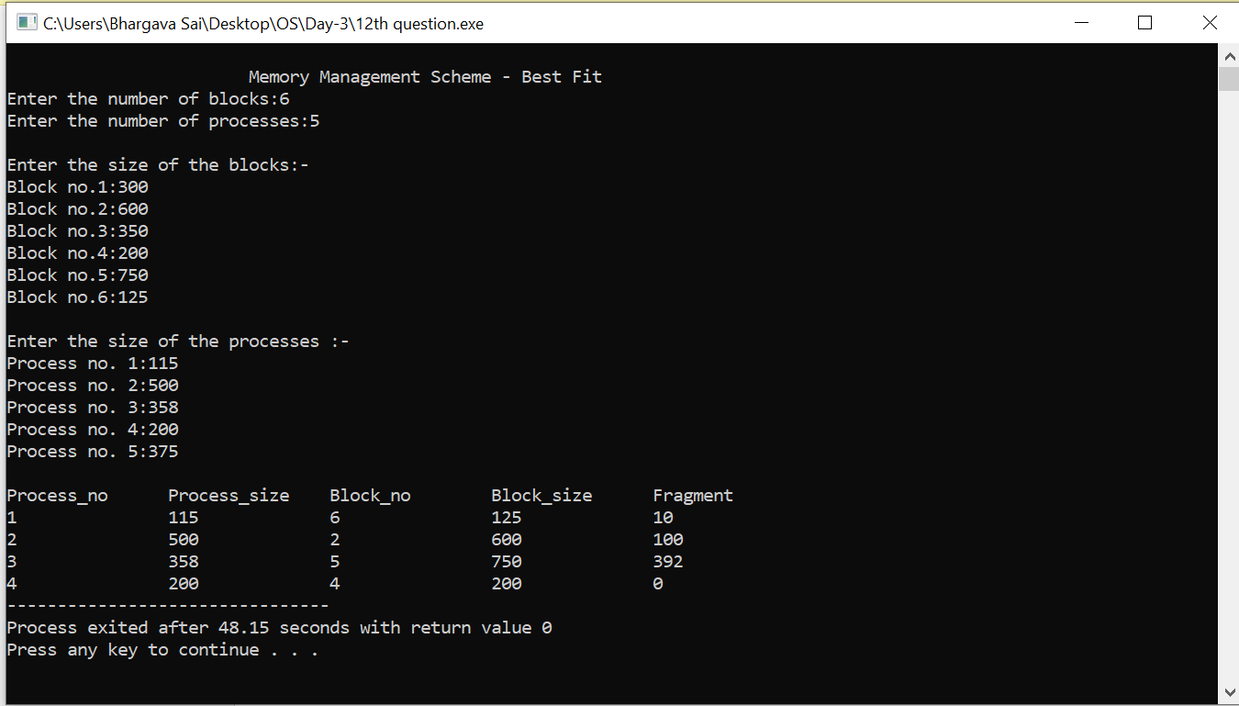

13. #include<stdio.h>

#include<conio.h>

#include<string.h>

int main()

{

int nf=0,i=0,j=0,ch;

char mdname[10],fname[10][10],name[10];

printf("Enter the directory name:");

scanf("%s",mdname);

printf("Enter the number of files:");

scanf("%d",&nf);

do

{

printf("Enter file name to be created:");

scanf("%s",name);

for(i=0;i<nf;i++)

{

if(!strcmp(name,fname[i]))

break;

}

if(i==nf)

{

strcpy(fname[j++],name);

nf++;

}

else

printf("There is already %s\n",name);

printf("Do you want to enter another file(yes - 1 or no - 0):");

scanf("%d",&ch);

}

while(ch==1);

printf("Directory name is:%s\n",mdname);

printf("Files names are:");

for(i=0;i<j;i++)

printf("\n%s",fname[i]);

getch();

}

Output

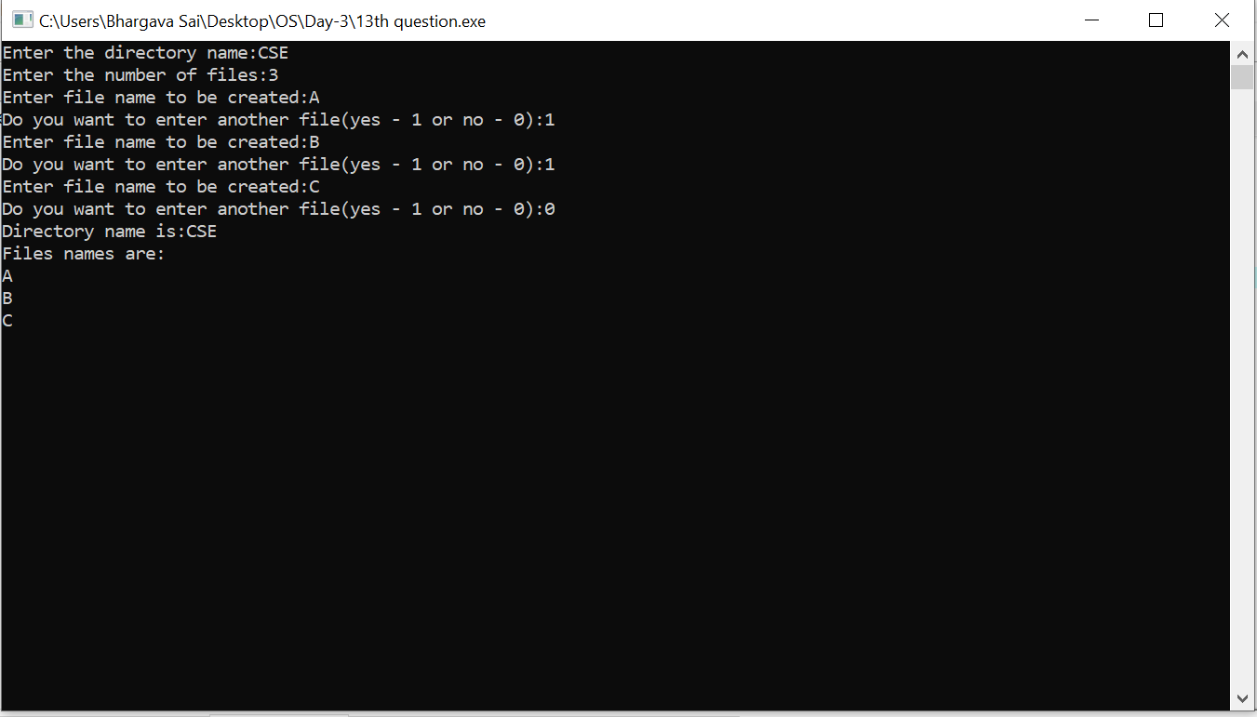

14. #include<stdio.h>

int main()

{

int no_of_frames, no_of_pages, frames[10], pages[30], temp[10], flag1, flag2, flag3, i, j, k, pos, max, faults = 0;

printf("Enter number of frames: ");

scanf("%d", &no_of_frames);

printf("Enter number of pages: ");

scanf("%d", &no_of_pages);

printf("Enter page reference string: ");

for(i = 0; i < no_of_pages; ++i){

scanf("%d", &pages[i]);

}

for(i = 0; i < no_of_frames; ++i){

frames[i] = -1;

}

for(i = 0; i < no_of_pages; ++i){

flag1 = flag2 = 0;

for(j = 0; j < no_of_frames; ++j){

if(frames[j] == pages[i]){

flag1 = flag2 = 1;

break;

}

}

if(flag1 == 0){

for(j = 0; j < no_of_frames; ++j){

if(frames[j] == -1){

faults++;

frames[j] = pages[i];

flag2 = 1;

break;

}

}

}

if(flag2 == 0){

flag3 =0;

for(j = 0; j < no_of_frames; ++j){

temp[j] = -1;

for(k = i + 1; k < no_of_pages; ++k){

if(frames[j] == pages[k]){

temp[j] = k;

break;

}

}

}

for(j = 0; j < no_of_frames; ++j){

if(temp[j] == -1){

pos = j;

flag3 = 1;

break;

}

}

if(flag3 ==0){

max = temp[0];

pos = 0;

for(j = 1; j < no_of_frames; ++j){

if(temp[j] > max){

max = temp[j];

pos = j;

}

}

}

frames[pos] = pages[i];

faults++;

}

printf("\n");

for(j = 0; j < no_of_frames; ++j){

printf("%d\t", frames[j]);

}

}

printf("\n\nTotal Page Faults = %d", faults);

return 0;

}

Output

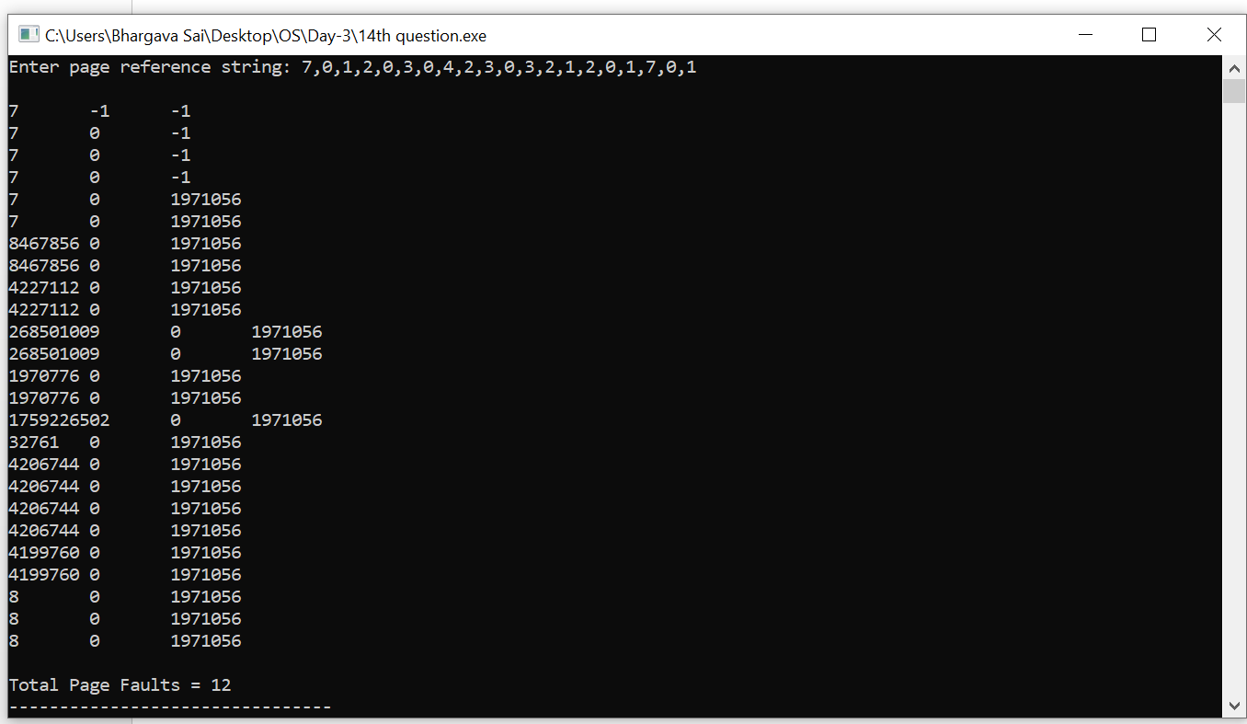

15. #include <stdio.h>

#include <math.h>

int size = 9;

void FCFS(int arr[],int head)

{

int seek_count = 0;

int cur_track, distance;

for(int i=0;i<size;i++)

{

cur_track = arr[i];

distance = fabs(head - cur_track);

seek_count += distance;

head = cur_track;

}

printf("Total number of seek operations: %d\n",seek_count);

printf("Seek Sequence is\n");

for (int i = 0; i < size; i++)

{

printf("%d\n",arr[i]);

}

}

int main()

{

int arr[9] = {55,58,60,70,18,90,150,160,184};

int head = 50;

FCFS(arr,head);

return 0;

}

Output

